**1)** **Write a query to calculate the percentage contribution of each item's amount to its order's total amount, grouped by order_id. (Topics: Partition BY)**

SELECT order_id, item_id, amount,

amount / SUM(amount) OVER (PARTITION BY order_id) * 100 AS percentage_contribution

FROM "Local".items;

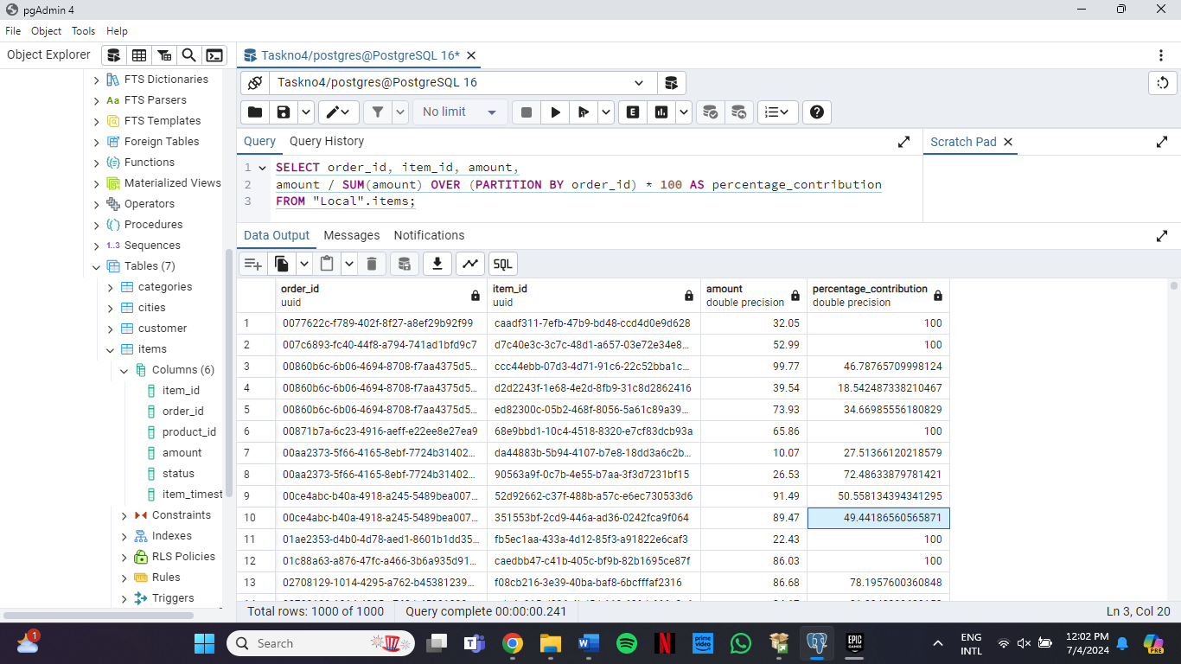

**2)** **Write a query to rank orders by their total amount within each customer, ordering them from highest to lowest total amount. (Topics: Window functions like RANK, PARTITION BY, and ORDER BY)**

SELECT customer_id, order_id, total_amount,

RANK() OVER (PARTITION BY customer_id ORDER BY total_amount DESC) AS order_rank

FROM (

SELECT customer_id, order_id,

SUM(total_amount) AS total_amount

FROM

"Local".orders

GROUP BY

customer_id, order_id

) AS order_totals

ORDER BY

customer_id, order_rank;

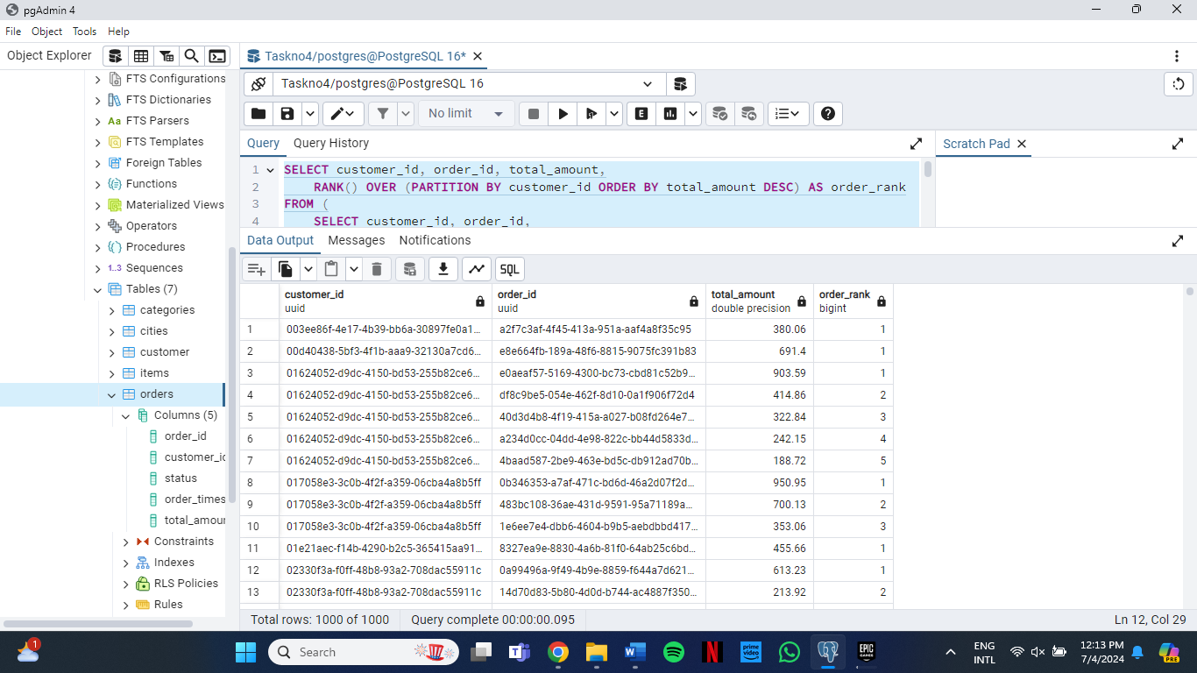

**3)** **Write a query to calculate the average price of products supplied by each supplier. Exclude suppliers who have no products in the result. (Topics: JOINS, AGGREGATE FUNCTIONS, GROUP BY)**

SELECT

s.supplier_id, s.name,

AVG(p.price) AS average_price

FROM

"Local".suppliers s

JOIN

"Local".products p ON s.supplier_id = p.supplier_id

GROUP BY

s.supplier_id, s.name

HAVING

COUNT(p.product_id) > 0;

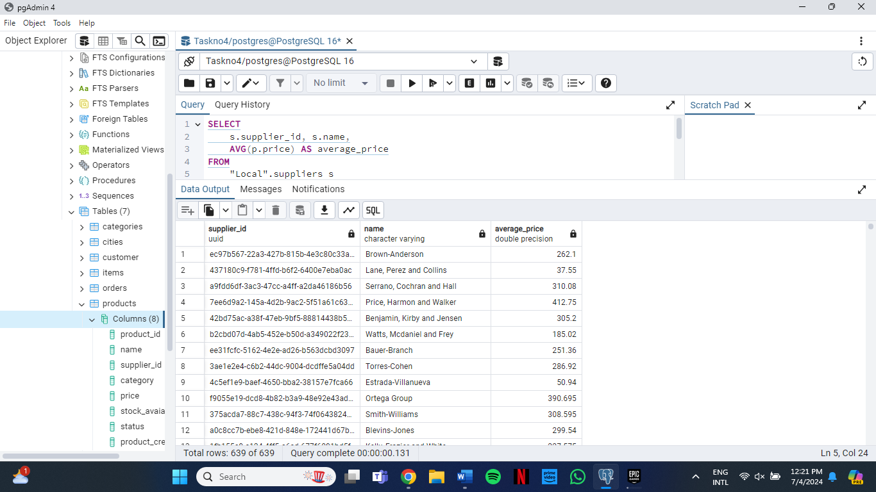

**4)** **Write a query to count the number of products in each category. Include categories with zero products in the result set. (WINDOW FUNCTIONS, AGGREGATE FUNCTIONS, JOINS, GROUP BY)**

SELECT c.category,c.name,

COUNT(p.product_id) AS product_count

FROM "Local".categories c

LEFT JOIN "Local".products p

ON c.category::text = p.category

GROUP BY c.category,c.name;

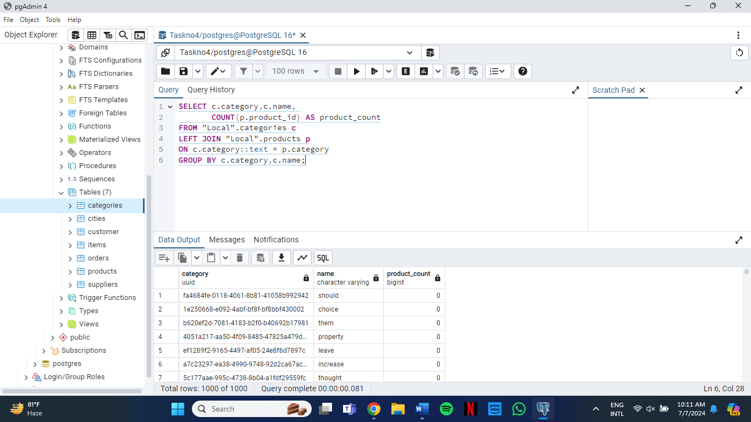

**5)Write a query to retrieve the total amount spent by each customer, along with their name and phone number. Ensure customers with no orders also appear with a total amount of 0. (WINDOW FUNCTIONS, AGGREGATE FUNCTIONS, JOINS, GROUP BY)**

SELECT c.customer, c.name, c.phone,

COALESCE(SUM(o.total_amount), 0) AS total_amount_spent

FROM

"Local".customer c

LEFT JOIN

"Local".orders o ON c.customer = o.customer_id

GROUP BY

c.customer, c.name, c.phone

ORDER BY

c.customer;

